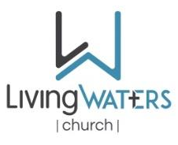

LIVINGWATERS CHURCH
Family Business Meeting Agenda – Sunday, Sept. 14, 2025, 11AM

Opening Prayer & Call to Order ~ Gary Jarvis - Church Moderator

Open Arms ~ Pastor Rob

Obstacles Removed ~ Gary Jarvis

Finance Report ~ Dean Minnie – Church Financial Secretary

Opportunities Pursued ~ Elders – current team

One Church assignment ~ Pastor Scott

Observations ~ Church Body

Closing Prayer

